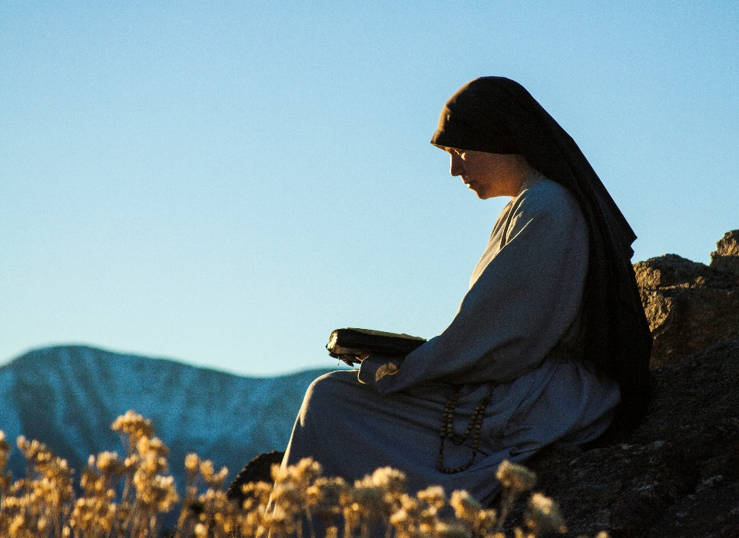
For Love Alone
Film Synopsis – Long

“A woman came to him with an alabaster jar of costly perfumed oil. She broke the jar and poured out the oil.”
So begins the Grassroots film For Love Alone, a recent film on women’s religious life made to complement Fishers of Men. The seventeen-minute impact film uses the testimony of religious sisters, their family members, and even those they serve, as well as powerful images and music, to convey to the world the beauty of religious life.
As the body of the film begins, sisters reflect on their earlier lives and on that initial experience of a “call.” Viewers may be surprised to see photos of them at proms, sporting events, and otherwise normal adolescent activities, and in fact many of them seem to stumble upon the possibility of religious life almost by accident. Eventually, however, they each describe growing deeper in prayer and facing the question: “Is God calling me to that?”
Particularly poignant is the testimony of a father, who describes walking with his daughter as she went from initially discerning a vocation to entering a religious community. Beginning with the moment when his daughter called home from college to say, “Mom and Dad, I think I have a religious vocation,” and carrying through the difficult moments in which some of his other children reacted negatively to her vocation, he relates with honesty what the experience was like from a parent’s perspective.
The sisters are forthright about the challenges of their vocational path too. One sister puts it: “It isn’t always easy to be a bride of Christ. It isn’t easy to be a bride of anybody.” Yet they all concur that when they entered their respective communities, they found that they’d become part of a religious family, and the camera captures numerous clips of their day-to-day lives. “We eat together, we wash dishes together—we really live our lives together,” explains one sister. Pointing toward the importance of prayer in their life, another says, “We start with prayer, we finish with prayer, and every religious community finds [its] source at prayer life.” Thus do they show that the “family life” of the convent provides the foundation for the life of service they’ve undertaken.
As for what form this service takes, the film portrays a rich variety of examples—care for children, the poor, the sick, the elderly—but it gives particular attention to end-of-life care. Shots of sisters curling their dying patients’ hair, filing their fingernails—in a word, accompanying them through their last days—coincide with testimonies from the patients themselves, repeatedly affirming how much the sisters feel like family. “I’m very lucky to have the help I get here,” says one patient with great emotion. “It’s not even help, it’s caring.” In a sobering moment, the film reveals that at least two of the patients have passed away since the filming of their interviews, having lived out their final days with dignity under the care of sisters.
The music then begins to rise as the film moves into a discussion of the deepest core of religious life—espousal to God and spiritual motherhood. “You’re not running away from the idea of marriage,” explains one sister. “You’re running toward a marriage with God himself.” Another attests: “The Church is in need of mothers, and that’s what sisters do—they enter in as spiritual mothers.” Eventually, words give way to images and music as the camera flashes between scenes of sisters at prayer and sisters living out their spiritual motherhood in the world. At a particularly powerful moment, the film simply goes silent and the camera cuts to a sister in Adoration of the Blessed Sacrament, her eyes locked on the Eucharist in a gaze of love.
A unique perspective on this kinship of prayer and service is offered by one speaker in particular—a Missionary of Charity sister who learned at the knee of Mother Teresa herself. Speaking of the now-canonized saint, she says, “She taught us to fall in love with Jesus, to have great love and intimacy with Jesus. That is the core of our religious life,” and, “Prayer and service go hand-in-hand. Jesus came himself and said, ‘I came among you as a servant.’ For service.” Thus in a way does she make present in the film the voice of Mother Teresa, no doubt the most famous woman religious of the last century.
As the film winds down, the sisters reflect on the gift of their call with awe and gratitude. One, who had initially expressed trepidation at the thought of a vocation, affirms: “The gift of this call is really the greatest gift of my life.” They also express confidence that, “Although it is hard to hear in our world, the call is still there.” An accompanying shot of a large, completely full convent chapel certainly seems to support her claim. But as a sister says earlier in the film, “One thing it is for God to call, but another is to respond, and to respond generously, promptly, courageously, and joyfully.”
“Amen I say to you, wherever the gospel is proclaimed in the whole world, what she has done will be told in memory of her,” finishes the verse from the Gospel of Matthew that began the film. The verse, like so many of the images in the film—indeed, like a religious vocation itself—is charged with meaning, and leaves much to the viewer to ponder.
Cutting through common misconceptions, portraying the drama of a vocational journey with vividness and honesty, and capturing the beauty of the life with fresh and captivating artistry, For Love Alone will leave any viewer with an unforgettable insight into the mystery of a religious vocation.

