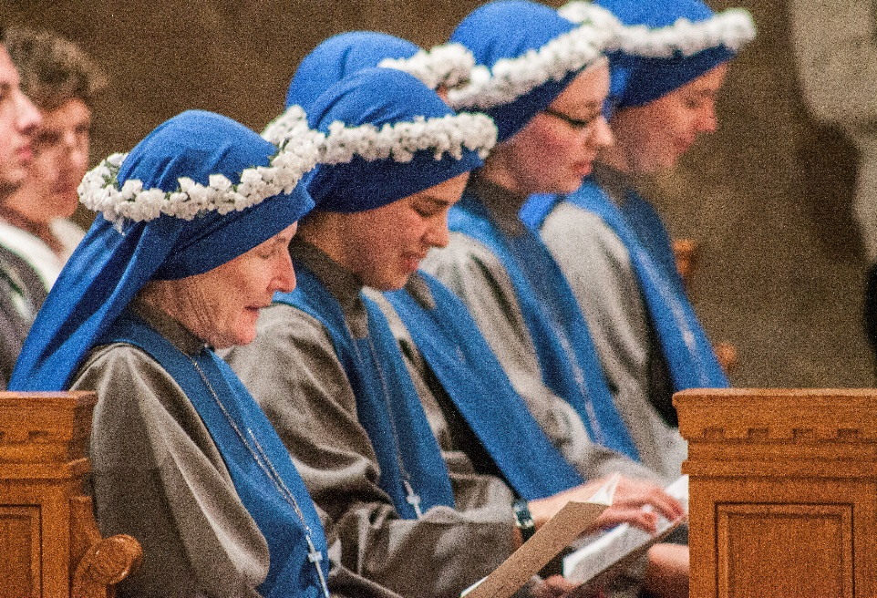
For Love Alone
Film Synopsis – Medium
For those who enjoyed the Grassroots film Fishers of Men, which showcases the vocation to the priesthood, For Love Alone will prove a worthy complement. This seventeen-minute impact film uses the testimony of religious sisters, their family members, and even those they serve, as well as gripping images and music, to convey to the world the beauty of religious life.
The film begins as sisters reflect on their earlier lives and on that initial experience of a “call.” Viewers may be surprised to see photos of them at proms, sporting events, and otherwise normal adolescent activities, and in fact many of them seem to stumble upon the possibility of religious life almost by accident. Eventually, however, they each describe growing deeper in prayer and facing the question: “Is God calling me to that?”
The decision is not an easy one, as they and their family members attest. One sister puts it: “It isn’t always easy to be a bride of Christ. It isn’t easy to be a bride of anybody.” Yet when they enter their respective communities, they find that they’ve become part of a religious family, and the camera captures numerous clips of their day-to-day lives. “We eat together, we wash dishes together—we really live our lives together,” explains one sister. Pointing toward the importance of prayer in their life, another says, “We start with prayer, we finish with prayer, and every religious community finds [its] source at prayer life.” Thus does the “family life” of the convent provide the foundation for a life of service they’ve undertaken.
As for what form this service takes, the film portrays a rich variety of examples—care for children, the poor, the sick, the elderly—but it gives particular attention to end-of-life care. Shots of sisters curling their dying patients’ hair, filing their fingernails—in a word, accompanying them through their dying days—coincide with testimonies from the patients themselves, repeatedly affirming that the sisters feel like family. “I’m very lucky to have the help I get here,” says one patient with great emotion. “It’s not even help, it’s caring.”
The music then begins to rise as the film moves into a discussion of the deepest core of religious life—espousal to God and spiritual motherhood. “You’re not running away from the idea of marriage,” explains one sister. “You’re running toward a marriage with God himself.” Another attests: “The Church is in need of mothers, and that’s what sisters do—they enter in as spiritual mothers.” Eventually, words give way to images and music as the camera flashes between scenes of sisters at prayer and sisters living out their spiritual motherhood in the world. At a particularly powerful moment, the film simply goes silent and the camera cuts to a sister in Adoration of the Blessed Sacrament, her eyes locked on the Eucharist in a gaze of love.
As the film concludes, the sisters reflect on the gift of their call with awe and gratitude. One, who had initially expressed trepidation at the thought of a vocation, affirms: “The gift of this call is really the greatest gift of my life.” They also express confidence that, “Although it is hard to hear in our world, the call is still there.” An accompanying shot of a large, completely full convent chapel certainly seems to support her claim.
Cutting through common misconceptions, portraying the drama of a vocational journey with vividness and honesty, and capturing the beauty of the life with fresh and captivating artistry, For Love Alone will leave any viewer with an unforgettable insight into the mystery of a religious vocation.

