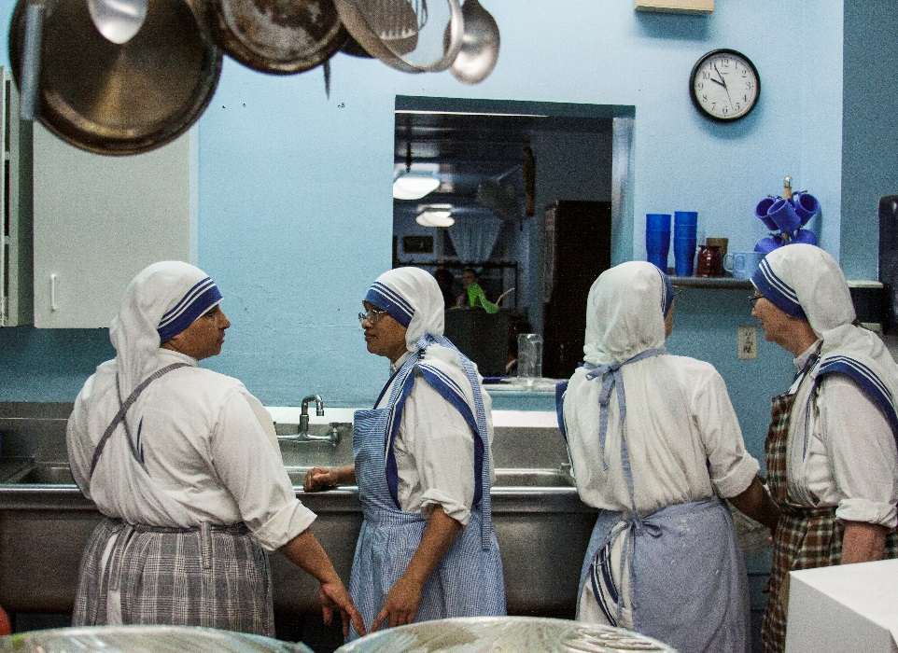
For Love Alone
Film Synopsis – Short
For those who were enthusiastic about the Grassroots Film Fishers of Men, which showcases the vocation to the priesthood, For Love Alone will prove a worthy complement. This seventeen-minute impact film uses the testimony of religious sisters, their family members, and even those they serve, as well as gripping images and music, to convey to the world the beauty of religious life.
As For Love Alone begins, the sisters reflect on their earlier lives, as well as on that initial experience of a “call.” The film moves quickly, however, into an inside look at their lives now, beginning with prayer and common life and flowing into a life of service. The film gives particular attention to the timely example of sisters who work in end-of-life care, and it culminates in a discussion of the deepest core of religious life—espousal to God and spiritual motherhood. While the speakers give great respect to the married vocation and are honest and forthright about the challenges of living out their vocation, they ultimately affirm that the religious calling still exists, is still relevant, and is still a great gift.
With a startling degree of beauty, poignancy, and drama, For Love Alone will leave any viewer with an unforgettable insight into the mystery of a religious vocation.

