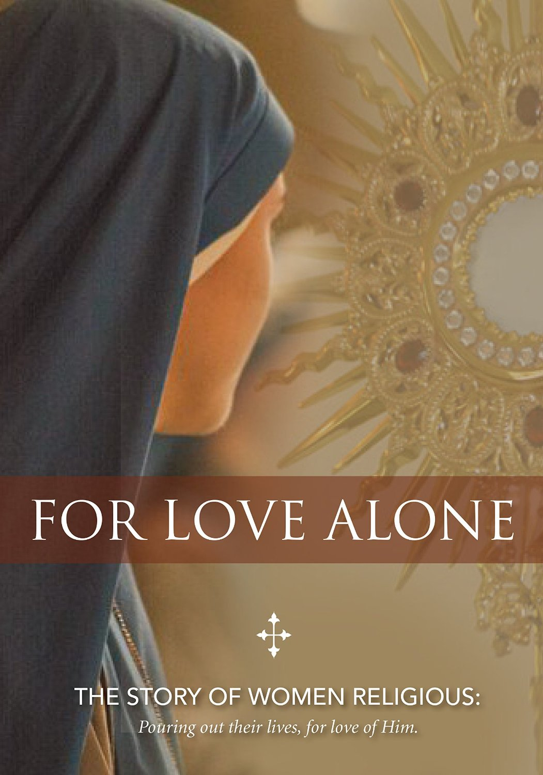

Grades 9-10: FOR LOVE ALONE
The Story of Women Religious

• PREPARATION – How to Get Ready

Materials: “For Love Alone” video; PowerPoint Lesson, including the Scripture reference; A copy (either print or electronic) of a combined account of the anointing at Bethany (See Appendix A)

- It might be appropriate for the catechist to review the paragraphs from Canon Law, which convey that this form of life includes life in common, and separation from the world (distinguishing religious institutes from secular institutes or other forms of consecrated life).
  - Can. 607 §1. As a consecration of the whole person, religious life manifests in the Church a wonderful marriage brought about by God, a sign of the future age. Thus the religious brings to perfection a total self-giving as a sacrifice offered to God, through which his or her whole existence becomes a continuous worship of God in charity.
  - §2. A religious institute is a society in which members, according to proper law, pronounce public vows, either perpetual or temporary which are to be renewed, however, when the period of time has elapsed, and lead a life of brothers or sisters in common.
  - §3. The public witness to be rendered by religious to Christ and the Church entails a separation from the world proper to the character and purpose of each institute.
- In the PowerPoint to accompany this lesson there is a QR code to the CMSWR web page to further explain what is meant by religious life.

Preparation: Prior to watching the video For Love Alone, the students will view the art piece of the anointing at Bethany (in Power Point Lesson), and read the account of the Anointing at Bethany from the four Gospels, and excerpts of which are threaded throughout the video For Love Alone. Ask the following questions:
- In this account from the Gospels, why do you suppose this woman is performing this act of anointing?
- What is considered to be wasteful about her action?
- Does Jesus consider what the woman is doing to be wasteful? How do you know? What adjective does he use to describe what she does for Him?
- Take a few moments to view the art work of the anointing. What do you notice about the expression of the figures in the painting?

• PROCLAMATION – Main Theme

To draw a connection between the Gospel vignette of the woman with the alabaster jar and the call to a religious vocation; and to arrive at the notion (as in the case of the woman at Bethany) that religious life is a “beautiful thing”: total self-giving love.

• EXPLANATION – Content of Lesson

- First, explain what is meant by “religious life.”
  - What is not meant here is a person who happens to be “religious” by going to church and praying.
  - What is meant is a way of life in which men and women vow to live the three vows of poverty, chastity, and obedience, in service to the Lord and His people.

- Before watching For Love Alone consider:
  - In the story of the woman anointing Jesus at Bethany, the woman is accused of wasting the perfumed ointment. Discuss that this Scripture is threaded throughout this video on religious life. Ask the young people why they suppose this is the Scripture chosen as the motif for a video on religious life.
- Watch For Love Alone.
- After watching For Love Alone:
  - Revisit the pre-video question: Why do you suppose the episode of the woman anointing Jesus’ feet is the Scripture chosen as the motif for a video on religious life?
  - Religious Life is for love alone:
    - How does the video express religious life as an extravagant outpouring of the gift of self to God and His people?
    - Are there moments in which it is obvious that the life of a religious is anything but a “waste?”
- The short section about the life and work of Mother Teresa excellently illustrates the notion that people considered her work in the slums of Calcutta to be a waste; yet, she believed, as did many others, that it was doing “something beautiful for God.”
- Did people think her life was a waste?
- Why is she a model for religious life?
  - One political journalist criticized Mother Teresa for putting a Band-Aid, figuratively, on the problem of hunger and sickness in Calcutta and for not really fixing the problem.
  - Several other critics accused her of exploiting the poor people of India.
  - Yet, thousands of people who were unloved and unwanted experienced God’s infinite love through her; her work extends well beyond the confines of one country, but touches the hearts of all people, for she was working “for love [of God] alone.”
- Reconnect to the story of the woman who anoints the head and feet of Jesus.
  - Why does this woman perform this beautiful act for the Lord?
  - If you were someone in this scene, who would you be and why (now that you have seen “For Love Alone”)?

• APPLICATION – Connecting it to Students

- Have students write a reflection answering the last question: If you were someone in the scene of the anointing of Jesus, who would you be and why (now that you have seen For Love Alone)?
- Have the students express either in a written essay or through some other means such as art, collage, “wordle,” poetry, etc., how their view of religious life changed after watching For Love Alone.
- Brainstorm questions as a class to ask a Sister in one of the communities represented in For Love Alone. Then have the students/young people write to a community in the CMSWR. A QR code has been provided in the PowerPoint slides for the young people to scan and look up a community they might wish to write.
- Have the students/young people read the vocation stories posted on the websites of the communities in the CMSWR. Ask them to share what struck them the most about reading a Sister’s individual story.

• CELEBRATION - Conclusion

- Watch the video or listen to the song “Small Things with Great Love” by Danielle Rose: https://safeshare.tv/x/ss58755a032e840.
- The lyrics of this song are filled with quotes from Mother Teresa, and they can be found on Danielle Rose’s own website: http://daniellerose.com/album-lyrics/i-thirst/
- The refrain ends “… and make my life something beautiful for God.”

